**Problem: "Planning a Weekend Getaway"**

You and your friends want to plan a weekend getaway to a nearby hill station. However, you need to consider various factors such as budget, transportation, accommodation, and activities to make the best decision. Use problem-solving techniques and create a flowchart to help guide your decision-making process. **ANSWER-**

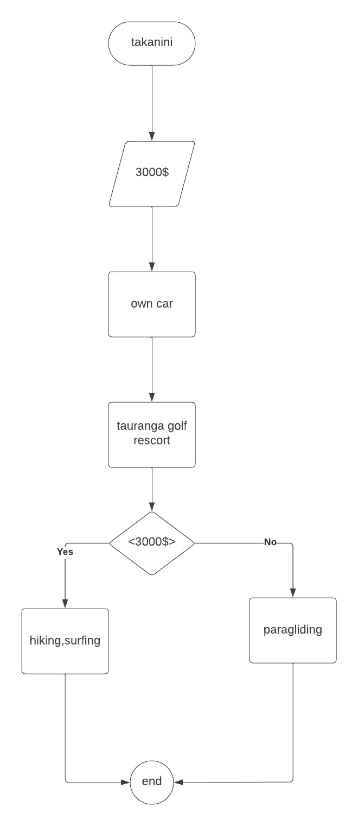

STARTING FROM TAKANINI WITH 3000 BUDGET PREFER TO GO BY OUR OWN CAR THEN WE WILL STAY AT TAURANGA GOLF CLUB AFTERWARDS WE WILL SEE THE LIST OF ACTIVITIES WHICH CAME IN OUR BUDGET THEN WE WILL CHOOSE THEM AFTERWARDS OUR TAURANGA TRIP WILL BE FINISHED